

**Department of Computing**

**Te Horo Rorohiko**

**CH3880 Bachelor of Information and Communications Technology**

**BCCE301 Cooperative Education Project**

**Semester 2, 2017**

**JavaScript Online Quiz for Moodle3**

**Ara Institute of Canterbury**

**FINAL REPORT**

<Daming Zhang>

<99137058>

Table of Contents

1 Introduction 2

2 Executive Summary of JavaScript online quiz 3

3 Background 4

4 Overview of objectives 5

5 Outcomes 7

5.1 Industry Outcomes 7

5.2 Academic Outcomes 7

5.3 Personal Outcomes 7

5.4 Comparison of Initial and Actual Outcomes 8

6 Progress Made 10

6.1 Overview of objectives 10

6.2 Milestones achieved 10

6.3 Problems encountered 13

7 Course Management 15

8 Review of previous courses 16

8.1 BCPR282 Best Programming Practices (Java) 16

8.2 BCIT388 Mobile Technology 16

8.3 BCPR203 Database Management Systems 17

8.4 BCCE301 Cooperative Education Project 17

8.5 BC280 Software Engineering 2 17

8.6 BCIS301 Management of ICT 18

9 Risk Management 19

10 Quality Assurance 21

11 Methodology Summery 23

12 Main Areas of Learning 24

12.1 Communication skills 24

12.2 Deeper understanding of JavaScript 24

12.3 Time management 24

12.4 GitHub for version control 24

12.5 Technical skills 24

12.6 Self-assessment 25

13 Evidence for Assessment Achievements 27

13.1 Activities Screen shots 27

13.2 Github code version control and document management screen shot 27

14 Conclusion 28

15 Appendices 29

16 Reference: 31

# Introduction

This report gives the summary of what I have done in the project. The final report is 31 pages in total. It covers these aspects:

* The explanation of the project and its background
* How the project was planned and implemented
* The achievements of the project
* How the project was managed using the Extreme Programming plan
* Evaluation of Quality Assurance(QA) programs and risk management programs
* A conclusion of this report with the methodology essay summary, agile for software management.

# Executive Summary of JavaScript online quiz

Anne Wignall is a retired teacher of science and chemistry who is now a textbook author. Recently, Anne has devoted herself to create a number of computer activities to help students study on Moodle.

My mission is using JavaScript to recreate the quizzes, translate them from Flash into HTML and make these quizzes available on Moodle 3. The quizzes also needed to be run on smart phones and tablets (Android & iOS).

My tasks were:

* Diagram:
  + Dragging the correct keyword answer label into the appropriate box, the positions of the boxes display random coordinates each time.
  + Input the right answer into the appropriate boxes the position of the boxes display random coordinates each time.
  + Dragging the correct image answer label into the appropriate box, the positions of the boxes displayed base on the XML file.
  + All the types of Diagram needs to display score base on the how well users answer the quiz.
* Hangman: Filling the blanks of missing words of a definition and show the process of getting the all of the words right. Record the letters that are not in the answer. It also needs to record the score. The answers and question are created base on the XML file.

The outcome were in 3 parts: (See the detail on page 7)

* Industry outcomes
* Academic outcomes
* Personal outcomes

The problems encountered were in two parts: (See the detail on page 19)

* Software Management
* Personal factors

Main areas of learning were: (See the detail on page 24)

* How to communicate with client effectively.
* Best practice associated with HTML, JavaScript and CSS.
* Deeper understanding of using MVC design pattern.
* How to manage project and course to ensure the Quality Assurance.
* Improve the ability of analysis and managing project risks.

# Background

Anne Wignall is a retired teacher of science and chemistry. She is also a textbook author. In recent few years, Anne has devoted herself to create a number of computer activities to help student to study on Moodle. Anne wishes to perfect Diagram quiz and Hangman exercise.

Anne uses a tool called Hot Potatoes to create the quizzes. The plugin Hot Potatoes plugin allows quizzes to be run on Moodle. The version of Moodle on Anne’s PC is Moodle2. The school she works in are using Moodle 3 now, which is part of the reason of recreating the project. The issues were:

Diagram:

1. It can not work on Moodle3 environment. It cannot get mark from Moodle.
2. Each time that the diagram generated has different coordinate of answer boxes, The boxes always keep in the same position in the diagram at the moment, so when users do the diagram quiz they may just remember the order of the answer not really know the answer match what part in the picture.

Hangman:

1. It has not to be set as an activity on the Moodle now. It cannot get mark from Moodle.
2. Anne wants students to fill in a whole sentence or a short paragraph by guessing letters until they can determine the missing words. Also the Hangman needs to calculate how many times users can get wrong. Some sort of gamification such as an animation that includes bombs, explosions or crashes when letters are wrong is desirable but not essential.

There is a table of “initial and final outcomes”, see page 7.

# Overview of objectives

In this section, It introduce the objectives of the project, showing what the required outcomes.

The goal for this project was all the activities had to work on Moodle 3, they need to work with Firefox, Chrome, Safari. They need to work on mobile devices with touch screens, both iOS and Android, desktops, and laptops. Users are primarily students in the third world.

Halfway into the project, some new features were added and some activities were cancelled, the outcomes have been re-negotiated, here are the details:

Before the halfway, the original plan for my client is to create 4 activities:

Diagram with two types, input type and drag type;

Hangman with animation;

Chemical diagram;

Better solution of multiple circuit diagram answers;

During the development period by the halfway, the actual outcomes are

Diagram:

1. For drag type, the answer boxes and the point aiming at the picture need to be generated by random position each time users refresh the web page.
2. For input type, the label boxes’ background change colour by times that users get wrong answer input and if users get 4 times wrong answer. The correct answer will automatically display in the box and user can not change it.
3. For drag image type, it is quite similar with “drag type”, just using images boxes instead of answer boxes.
4. The score system make user to get different points base on the times they get right.

* First time users get correct gets 100% for the question
* Second time get 75%
* Third time gets 25%
* Users get no points by the fourth time.

1. 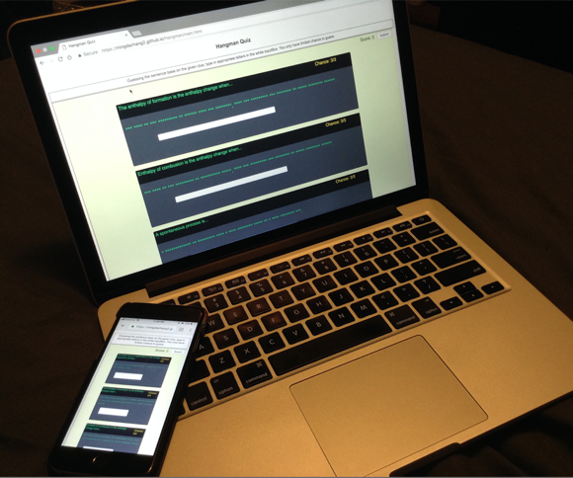Responsive design

The activities layout can fit different size of screen by different devices such as PC, smart phones. See the picture at right.

During the development of the Diagram project, I made a coordinate generator tool, so the client can create quizzes easily. This did not come from the original plan. The priority of the Diagram activity final outcome was completely finishing development and testing the “input” type and “drag” types on Moodle environment. In addition, there is an option feature which is dragging images instead of dragging labels. At the end, those three types have been implemented and tested on Moodle3 successfully.

Hangman: My client’s priority of the final outcome of the project is implementing the functions and testing on the Moodle3 environment.

The basic features are:

1. Guessing sentences base on the tips.
2. Setting an appropriate limited time of chance.
3. A recording score system to calculate score base on how many chances users are left.
4. Responsive design of the layout.

Also, I made some more features to make Hangman better

Such as:

1. To show the right answer in different colour to user.
2. Making noise when users putting wrong letters.
3. Getting random questions from the xml file instead of getting in an constant order questions.
4. To show and record the letters that users have typed incorrect.

As the project proceeds, the Chemical diagram and Better solution of multiple circuit diagram answers projects are cancelled. Because the priority is to get Diagram and Hangman perfect.

# Outcomes

In the section, It shows the outcomes from the project. It basically includes 3 parts.

## Industry Outcomes

The project has the following outcomes.

* Features that required
* The testing results
* The defect tracking
* API Documentation of the online quizzes for maintenance

## Academic Outcomes

* Project proposal
* Academic / Industry supervisor assessments
* Methodology essay
* Halfway report including
  + Risk management for project
  + Quality assurance for project
  + Review of 200 and 300 level courses

## Personal Outcomes

I have learnt the following skills and knowledge that I gained from doing the project

* Deeper understanding of JavaScript
* GitHub for version control
* How to set and configure Moodle3 environment
* Using jQuery to make the project easier
* Extreme programming for project management

## Comparison of Initial and Actual Outcomes

A table to illustrate the outcomes at different stages:

|  |  |  |  |
| --- | --- | --- | --- |
| Activity name | At beginning | At ½ way | At end |
| Diagram  (drag/input) | Was required at beginning.  1. Drawing a line to match box and point. Drag the appropriate answer card to the box.  2. Generate the boxes in certain order.  3. Only has drag type.  4. The first demo used the new xml configure file.  5. Responsive design. | 1. Replace drawing line to match box to creating colorful index to match box and point(The best solution of three options).  2. Generate boxes in a random position with the same color of point’s index.  3. An new “input” type of Diagram was developed, users have 4 chances to get a correct answer by inputting right letters, also change the background color to indicate the different stage where user at.  5. Fit the code to use the original xml configure file.  6. Set a passing score.  7. Implement the responsive design.  8. Creating an API guide documents for subsequent developer maintenance. | It has been implemented the required features at the end. |
| Coordinate Tool | Was not required | That is an extra work in order to help client easy to create quiz. It was finished before halfway. The tool can record the coordinates of a given point in a loaded picture. It also generate xml code automatically for client. | Change a quite few feature for this tool.  It has been implemented at the end. |
| Diagram(image) | Was not required | Was required in the halfway | It has been implemented all the basic functions, it could be better if proceed to develop |
| Activity name | **At beginning** | **At ½ way** | **At end** |
| Hangman | Was required at beginning.  The basic function of completing the missing word. An animation to show the process where user at. | Requirement was changed:  1. The animation was canceled.  2. Duplicated letter does not count for an extra input count.  3. Record the letters that users have put.  4. Record the wrong letter that users have put.  5. Get random questions from the questions list.  The Hangman project started in the beginning of halfway. | 1. Fix duplicated inputting same letter bug.  2. A more comfortable and colorful layout.  3. Set a label to show users’ chance.  4. Record the letters that users have put exist in the question.  5. Record the letters that users have put no exist in the question.  6. Put a cross and tick picture to indicate the question if is correct.  7. Show the correct answer with highlight letters which users can not guess out.  8. Get a certain number of a list of questions from xml file and questions are picked randomly out of all the question.  All the functions have been achieved at the end |
| Chemical quiz | Roughly plan | Cancelled in the halfway | Cancelled |
| Multiple circuit answers solution | Roughly plan | Cancelled in the halfway | Cancelled |

# Progress Made

In this section, it overviewed the objectives and showed the progress I made during the industry practise.

## Overview of objectives

The activities have to work on Moodle 3, they need to work with Firefox, Chrome, Safari. They need to work on mobile devices with touch screens, both iOS and Android, desktops, and laptops. Users are primarily students in the third world.

1. The project is aiming to fix all agreed problems to the existing resources. Each activity has different issues.

2. The activities also needed to implement new features that Anne required to add to these activities.

3. It needs to make the user more positive and motivating to use the quiz for studying on Moodle.

|  |  |
| --- | --- |
| Quiz name | Achievements |
| Diagram  (drag/input) | All objectives were achieved.   * Identify and fix all bugs * Modernise * Add new features and a tool * Improve maintainability with API document |
| Diagram(image) | * This was not in the original quiz list. Just start at the moment. |
| Hangman | All objectives were achieved.   * Identify and fix all bugs * Modernise * Improve usability * Improve maintainability with API document |

## Milestones achieved

An achievement list and a burndown chart to show where the milestones were achieved.

* The first picture is a burndown chart, it shows that a comparison of ideal and actual progress through 288 hours. We can see that I finished the project a little bit earlier form the chart.
* The second picture is a list to show the date of milestone I have achieved.

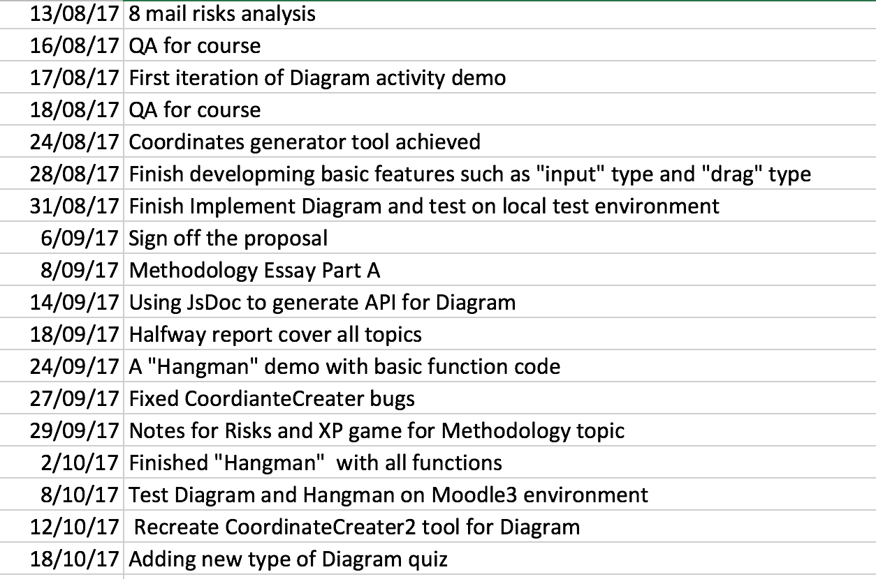

**Research of Diagram and Related Issues**

* Ensured the project was feasible.
* Achieved understanding of the required functionality.
* Diagram project demo under Github version control and a demo on the Github web page.
* Gained understanding of some common issues.

**Risk Management Plan**

* Risks analysis and plan details see page19

**Quality Assurance Plan**

* QA for course: Task list created to ensure the project meets or exceeds the required quality. See the details in Quality Assurance_A.docx file.
* QA for industry: Metrics defined for determining the success of the final product. See the details in Quality Assurance_I.docx file.

**Diagram Project Maintenance**

* Get knowledge of using JsDoc3 to generate API documents automatically.
* Tackled some major issues early.
* Used to refine project requirements.

**Diagram Project Functional**

* Diagram project created. Including two types of quiz: drag and input.
* Tested functionality on Chrome, Firefox, Safari browsers.
* Tested responsive design on Iphone6 and Android

**Diagram Coordinate Generator Tool**

* The coordinate generator tool created.
* Tested functionality on Moodle3 environment with Chrome, Firefox, Safari browsers.

**Hangman Project**

* Gain experience of JavaScript event binding.
* Tested functionality on Moodle3 environment with Chrome, Firefox, Safari browsers.

**Management of CE301 Course**

* Proposal: After meeting with client Anne, I took two days to get a proposal draft, after that I show it to my industry supervisor, academic supervisor and client, got feedback from them. Then modified it. I got it sign off by client on 6th Sep.
* Daily Plan: I met with my industry supervisor Mike on Monday every week to show him my plan of the whole week, wrote detail work for each hour. I studied about 6 hours on this course from Monday to Friday.
* Weekly report: I got feedback from the weekly meeting with Phillip, Luofeng and Mike, they gave me suggestions and tracked my process. In this way, it lead the course can be finish smoothly.
* Methodology Essay: My methodology essay topic is “Agile Project Management” It mentioned how the project run with using the programming method.
* Halfway report: In the Halfway report it mentioned the significant changes of the program and what has been re-negotiated.

## Problems encountered

**Project Management**

* Changed requirements: It is quite normal the requirement changed after meeting with client. I changed my original plan after I estimated the time consuming.

Sometimes adding an simple button was not as easy as it looks like, because the code is structural, I need to modify with several files, the CSS of html. Some potential problems or bugs may come out. Even I am not focusing testing at the moment but I still need to keep every function runs well, so after adding new code, I always test all the exist functions to ensure that the changes would not affect the original code. Another problem is some previous work may be useless or waste after getting new requirement.

* Features added: Same as changed requirement, sometimes client may propose some new features. The problem was quite like I mentioned with changed requirements. Adding new features needs to modify my plan and may change the logic of original work. Also I needed to modify everything that related to the code, such as API documents. In my case, I made a coordinate generator tool for my client which was out of the original plan. And after that, there were some new features that needed to add for the coordinate tool. I spent a lot time to research and create that tool, so I worked extra time in that week because I really wanted to get the project done perfectly.

In order to manage the project and nicely communicate to the client and get the client priority, I used agile extreme programming planning to better manage the project.

* API for maintenance: I used this tool to create Application Program Interface(API) documents for other developers to maintain the project in the future. My laptop is a MacBook, when I was first to get an API generator tool, I have tried to download a lot versions of JS generator tool.

Finally, I used JsDoc3 with NPM to solve the problem.

**Personal Factors**

* My personal English is not very good, sometimes I worked a lot and I thought I worked very effective, but my client may not know. Because sometimes I can not tell her more detail by English and she may not understand all my words. Also, a small change of the project may lead a big change to coding. I may fixed all the place that the code related to. A lot effort was behind the code. I needed to show her my work and let her be satisfied. I also needed to show a lot evidence to my supervisor to get the satisfaction. Because I am going to find a job in New Zealand, it is quite important for me to get a high grade.
* Research and study while developing HTML5 animation. I did not have enough knowledge of HTML5 animation, so I spent a long time for watching the tutorial from the Internet and did some practise for better understanding the knowledge. It impacted to the schedule.
* HTML5 drawing pictures with canvas were hard to achieve the responsive design, using DOM to draw can be responsive but it took a lot computer resources. Because browsers needed to draw quite a lot dot to make it looked like a line. A roughly number is 2000 dots make one line, and there are more than 10 lines. Which means browsers need to draw 20000 DOMs.
* The resources of using JavaScript are almost written in ES5 version from the Internet. I took a long time for researching.
* With doing the project, I also needed to study DataBase course and to finish the assignment in the last two weeks before half-way, I only reduced 4 hours work for project and took more than 8 hours on Database in that week. And I put extra 4 hours in the following week for the project. So both project and DataBase course went smoothly, I felt good where I were at that time.

# Course Management

In this section, it shows several ways that I could manage the course better and ensure the industry practise and course would be finished with a high quality.

**Time Management**

* MyHours track time log
* Plan the work for next week in detail

**CE301 Cooperative Education Project Class To Accompany Project**

* Track the process of the project and guide me a professional way to accomplish the project.

**Compromises In Other Aspects Of Life**

* Priority:

Online Quiz Project>CE301>PR203 >Exercise>Relaxation/Sanity> Social Life

**Daily Plan, Weekly Reports And Progress Meetings**

* Do daily plans for next week on every Monday after meeting client.
* Talk about where I’m at of the project. Major issues and successes with Dr. Mike and Dr. Luofeng.
* Check and discuss academic work with Phillip at least once a week.

**Effectiveness**

It is quite helpful and effective that records time consuming. Make a plan in details of every hour before the work of next week leads me to have more clearly goal. It also push me to work more concentrate for each day. I meet my supervisors three times once a week, they help me to give me idea and guide me to solve the problem I encountered. They also check my work of coding and report from previous week. It ensures that the project goes smoothly in every stage.

**Reflection**

It reduced stress when I was working, because everything has a roughly deadline. It gave me a big view of whole week and my supervisors gave me suggestions for the work at each stage. In the way, I can manage the project better, let me be able to finish the project confidently.

# Review of previous courses

In this section, it introduces the courses I have learnt. It shows what knowledge I used in the industry practise and recommendations for the courses.

## BCPR282 Best Programming Practices (Java)

* **Programming Best Practices**Best practices of separation of concerns, SOLID principles were taught in the class.
* **MVC In ES6**In the project, I used JavaScript program into MVC model. While I applied it into the project, it made the project more maintainable structural and easier to add more features.
* **Android Development**

The Android developing tool and skill were taught in the class and made an Android App in the final assignment.

**Recommendations**

This was a course that made me easy to get into the structural coding, separated the code into model, view, and controller standard. It was quite useful and easier to maintain in the future. No matter what programming language people use, the MVC design pattern is quite useful to separate application's concerns. On the other hand, the final assignment was about an Android App, it might be a little bit harder for a learner to make the App.

## BCIT388 Mobile Technology

This course taught technique knowledge of Mobile, such as the importance of complexity of password, the Wi-Fi and Li-Fi in people’s lives and Gamification. In the first several weeks we practised to design several small Android games by Google MIT App Inventor. It was quite easy and fun to quickly get start to develop Android App.

It also involved the knowledge about the mobile development, market, gamification and the design of mobile applications.

**Recommendations**

Gamification is a very important game principles that it encourages and improves people engagement. It can almost embed into everything to get a positive effects on individual’s ability to understand a certain area of study. I was required to put an animation game in my project, although it was cancelled, I still believed it was going to be attractive after adding that feature. On the other hand, as a level7 course, I suggest to put the Java Android lessons and final Android App assignment into this course.

## BCPR203 Database Management Systems

This course was aiming to understand the significance of Database Management Systems. To gain the knowledge and the technical skills of how to design, implement and manage a relational database in business. It also taught students how to write SQL statements. In the class, students practised to design database by real business case.

**Recommendations**

I chose this course because database knowledge are always combine with website project’s back-end. After I learnt this course I got a whole view of full-stack developer. It widened my knowledge and it was going to be very useful in the future. In my current project, I used xml file as database to configure and store information, however JSON is more sensible and acceptable than xml file. I think it will be better to teach more knowledge related to JSON in the class.

## BCCE301 Cooperative Education Project

This course gave the opportunities to students to communicate with technology industry. Let students learn different areas of technical computing skills and gained experience in an industry environment. Explaining the problems that were encountered in the project.

In the course students will also discuss the quality assurance and risk management base on the project

In addition, students needed to evaluate the 200 and 300 level (Level 6 & 7) courses that were helpful for the project and better support the project.

**Recommendations**

This course was more depend on self-learning. Supervisors gave students directions and helped students to solve problem.

What's more, the course helped students to track the process of project and ensured to accomplish the project.

However, the most time was on implementing the project to get client’s satisfaction. It will meet many areas of problems. It almost relies on students themselves to solve those problems and needed to get the supports from supervisors immediately. It saved time than thinking all by oneself.

## BC280 Software Engineering 2

This course was the most relevant in all the level 200 & 300 courses that I took. It taught JavaScript programming frameworks and practise the assignments with Personal Software Process (PSP) that was an Agile development process. This course was really like what I have done in the project. The agile development process was quite like what happened in the reality of industry, this course helped me a lot.

* **JSHint**A code checking and analysing tool that helps developers to find out errors and potential problems in JavaScript code. I used it combine with StandardJs in the project to check my JavaScript code..
* **Toggl**A tool for recording time consuming. I used this tool in course, but I am using MyHours instead in the project for the same purpose.
* **JavaScript ES6**  
  The latest version of JavaScript. I used this as main programming language in this project. A good thing about the course was that it involves pretty much coding, so I got used to writing JavaScript quickly. Taking this course at the same time helped a lot because I could ask programming questions in class.
* **Jasmine**This is a JavaScript testing framework. Write testing code follow the Jasmine syntax, then automatically check the functionality of each function in the code.

**Recommendations**

The course was the most useful for me. I have learned about Jasmine framework test automation and how to use Angular1 in ES6 to develop project. Angular is a quite popular development framework in the industry at the moment, I felt happy to learn it. However, Angular in ES6 version does not have enough resources in the Internet, it is almost in ES5 version.

## BCIS301 Management of ICT

This course was looking at the bigger view in ICT. It taught how to use frameworks to evaluate, analyse, and convincing solutions to studying IT governance. It also taught students to use COBIT framework for risk management.

* **Gathering Information**In the course, students got a task to practice to participate in an interviewing and gathering information with using the frameworks to gather and separate the information in order to analysis and evaluate the better choice of solutions.
* **Risk Identification And Evaluation**Students also learned a Risk IT framework, which is called COBIT. It explains risk into 4 main areas and I use this risk management knowledge in case study, created criteria of evaluation and the hierarchy of best option.

**Recommendations**

I used the skills from the course to evaluate potential options or solutions for my project. The course help me to give me a direction of thinking where risk from. But in fact, what we learn from the course is more about theory, we may lack of experience in the real project.

# Risk Management

In this section, it shows the risk evaluation. Also it introduces what risks I have met in the project.

Risks in the software developing can not be avoid, many reasons can slow down the project or even make the project fail. There were three parts of risk needed to consider.

1. **Project Risk – some factors could cause a project to fail**

1.1 Financial - the investment of the project was not enough;

1.2 Strategic – the requirement may change or need to add some new features;

1.3 Technical – the key technology of the project may not get enough support in the future;

1. **Production System Risk** 
   1. The production support team members may have not enough experience and skills sometimes.
2. **Personal Risk**

3.1 The degree or the knowledge of skill may not enough to support the project.

3.2 The impact on developers health and the emotional will effect the project schedule.

| **Risk name** | **Impact** | **Possibility** | **Exposure** | | **Mitigation** | **Contingency** |
| --- | --- | --- | --- | --- | --- | --- |
| **Member not familiar with the technology** | 80% | 80% | 64% | Schedule time for learning and researching | | To get support and helps from Academic and Industry Supervisor |
| **Requirements change or be added** | 60% | 70% | 42% | Check with the client’s priority. Then modify the plan of project | | Change project plan and take changes into the next weekly plan |
| **Testing environment not available** | 80% | 20% | 16% | Check available environment | | Build environment |
| **Too many bugs that not all can be fixed** | 80% | 20% | 16% | N/A | | Change project scope to fix only those of high priority |
| **Member sick** | 80% | 10% | 8% | Do not work day and night, having rest is important | | Have enough rest every day. |
| **Client is not available** | 30% | 20% | 6% | Get the client’s schedule beforehand | | Make plan to do things that I can do without the client |
| **Data lost** | 90% | 5% | 4.5% | Using GitHub and One Drive to manage the version control | | Download from repository  Or One Drive |
| **Budget might be needed** | 50% | 1% | 0.5% | Check if I can use budget and how much | | Select methods that do not need money |

**Effectiveness**

In order to finish the project, it is always good that try to predict the risks before they happen. After analysing the risks it reduce pressure when the risks come out. Because I have already give the solution. And the best way to solve the risk is preventing it not to happen. Such as I use Github for my project version control, so it significant decrease the rate that the Data lost risk happen.

**Reflection**

In the project, the risks I mentioned in the table were changed requirements and features added. I made a tool for my client to create quiz.

Because It was a free-pay project, so there was no budget risks. I put all the code and documents on the Github to save all the materials to prevent data losing. Another risk was I was lack of using HTML5 canvas to make animation, but this feature was cancelled.

The project was developed just only by myself. The project had never been interrupted because I have never gotten sick. My client were back from surgery and recovered very quick. We have not missed our weekly meeting.

# Quality Assurance

Quality Assurance is short for QA, which means the approaches of checking if a project meets the client’s requirements.

*List Of Deliverables*

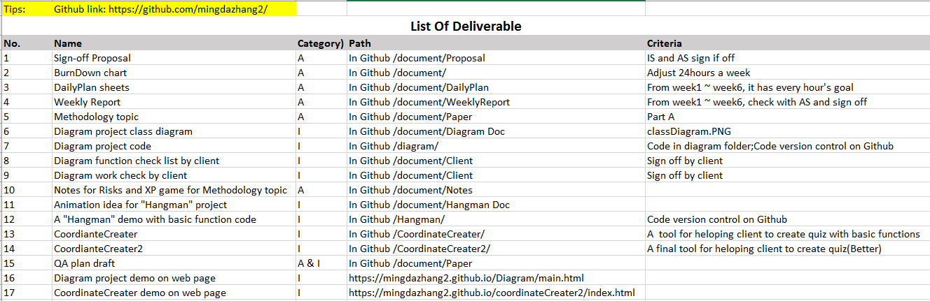

External characteristics of software quality

|  |  |  |
| --- | --- | --- |
| Quality | Description | Importance |
| Usability | How easy users can use or learn a system. | It is important that users can easy know what a system tell. |
| Adaptability | The ability of a [system](https://en.wikipedia.org/wiki/System) to adjust or adapt itself and fast to changed circumstances. | The quizzes should be supported by different browsers, including mobile devices, and tablets. |

Internal characteristics of software quality in priority order

|  |  |  |
| --- | --- | --- |
| Quality | Description | Importance |
| Readability | How easy a developer can understand the code of a system. | It is important to make developer easy to get started and review the code. |
| Maintainability | How easy developers can modify or add new features to a software system. | Important for maintenance purpose. |

**Effectiveness**

* Readability by maintainer: In order to making easier for maintainers, I wrote readable comments and modularity code to help maintainer s to understand the system quickly.
* Comments: It includes function header comments and line comments. Describe what happens for the code.
* Modularity: Make the code structural and clear, can be easy to add up new function or reuse the code for maintainers.
* Separate JS file: Separate the JS file into different file base on the class and design pattern
* Classes: Create classes base on the
* XML structure: The XML should be structural, it should not write every tag in one line. It needs to
* use indentation for each child tag.
* Functionality: The project should work as required, which means the project works. There are three main users that will use the project and care about the functionality.
* Client
* 3rd World students on mobile devices
* Teachers- create new quizzes by modify xml file

**Reflection**

With all those strategies and approaches I felt very confident to meet the goal at each stage.

* The structural code is quite effective to adding new features.
* Besides, building an API maintenance document instead of solving the problems by reminding and re-thinking the code when updating the code, it can avoid to waste time.
* Let the developer myself act a role as user, find out what my client really wants. First ensure the functionality of the project meets the requirement. Then, bring the result with more usability to client and it always along with supervise. As long as getting that point, client will be satisfied.

# Methodology Summery

My methodology essay topic is “Agile software management”. In the essay, I have introduced the Extreme programming methodology that I used in the project for agile management. Also talked about why I used it and why it is widely used for software development.

Extreme Programing(XP) as a common agile method, it was first used in the mid 1990’s (Wikipedia, 2017, para. 3). It is successful method because it leads customer to fell satisfied. With using this method, the process delivers the achievement as I plan it. Extreme Programming makes developers to respond confidently to changing requirements or adapting to client feedback.

In addition, I also mentioned how I used XP planning game in the project. XP emphasizes teamwork. Clients, managers, and developers are all equal important role in the collaborative team. It implements a simple and effective environment that encourages and enables developing teams to become highly productive (Wells, D. n.d., para. 2). During the programming period, I met my client Anne one a week. Every time after meeting the requirements changed or were added. It is quite normal happened in the industry. So a good strategy of effectively and clearly communication skill to negotiate with client is very important for managing the project.

Finally, I compared theory and actual work, it showed desired outcomes with using this method. Also discussed the possible different outcomes by the different situations.

# Main Areas of Learning

I have learnt the following skills and knowledge that I gained from doing the project.

## Communication skills

Because I met my client and tutors at least three times a week and we discuss issues and solution for around one hour in each meeting, which literally improved my communication skills and understand what my client want. It gives me a significance help to my career and development in the future.

## Deeper understanding of JavaScript

The project provided me an opportunity to practice JavaScript developing skills. It gave me a deeper understanding of JavaScript, it also gave me an excellent training of my self-learning ability.

## Time management

During the period of developing, I used MyHours to track time consuming, I learned how to manage time to enhance the productivity and effectiveness. Make a plan before working and solve the problems with discussing with industry supervisors also save time to solve issues.

## GitHub for version control

Version control helps to avoid losing files risks. What is more, because the code update very frequently and it is ineluctable that sometimes the code needs to go back for some reasons. Such as code comparison, detecting bugs.

Version control is also the management of changing documents and codes. In the project I use GitHub repository, which is the most popular and powerful tool for version control.to control versions. I got several iterations of code shows that the project was built up step by step along the time. I left comments to give each version a brief description in order to maintenance in the future.

## Technical skills

* Moodle as the programs work on Moodle
* jQuery to support multi-platform
* HTML canvas skills

## Self-assessment

**COURSE MANAGEMENT**

* established - course proposal signed off on 6 Sept 2017
* actively maintained – attend to class every time and do the work follow supervisor’s suggestion.
* extensive

I have learnt different areas of knowledge, like risk management, time track

* exceptionally effective

my work is always on track

* displaying excellent control

make a plan of the course through the whole semester

* initiating communication throughout its execution.

**THE PROJECT**

* completed the project
* to the industry supervisor’s satisfaction
* demonstrating an exceptional grasp of the subject.

CONTENT OF THE LEVEL 200 AND 300 COURSES

* correctly identified - all 6 courses are included
* evaluated content – see pages 16-19
* shows material has been applied in a relevant and innovative manner – see recommendation paragraphs on pages 16-19
* perceptive content recommendations

**QUALITY ASSURANCE PROGRAMME see page 22-23**

* created
* maintained
* applied
* comprehensive
* in-depth understanding
* critically analysed
* insightful conclusions

**RISK MANAGEMENT PROGRAMME see page 20-21**

* created
* maintained
* applied
* comprehensive
* in-depth understanding
* critically analysed
* insightful conclusions

**METHODOLOGIES ESSAY/REPORT – see my essay**

* extensively referenced accepted theory
* industrial practice
* related
* exceptional standard.

**REPORT**

* polished
* imaginative
* clearly and fluent
* insightful
* accurate grammar and spelling.
* very full analysis of performance

**POSTER**

* Imaginatively
* professionally
* displays project’s outcomes
* conveys learning achieved.

# Evidence for Assessment Achievements

This section shows the evidence of types of activities. More details in the attachments.

## Activities Screen shots

See more details in file ‘Evidence of activties.docx ‘

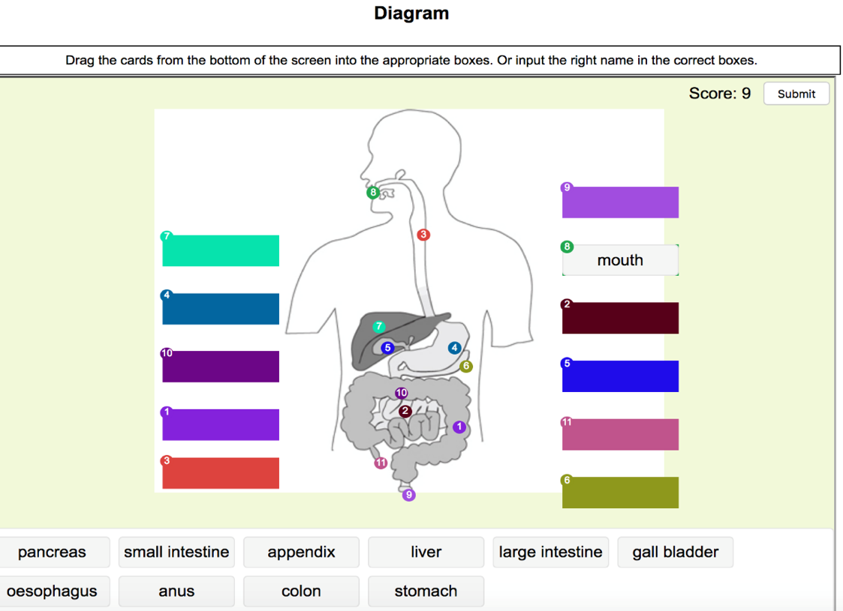

## Github code version control and document management screen shot

See more details in file ‘Evidence of maintenance.docx ‘

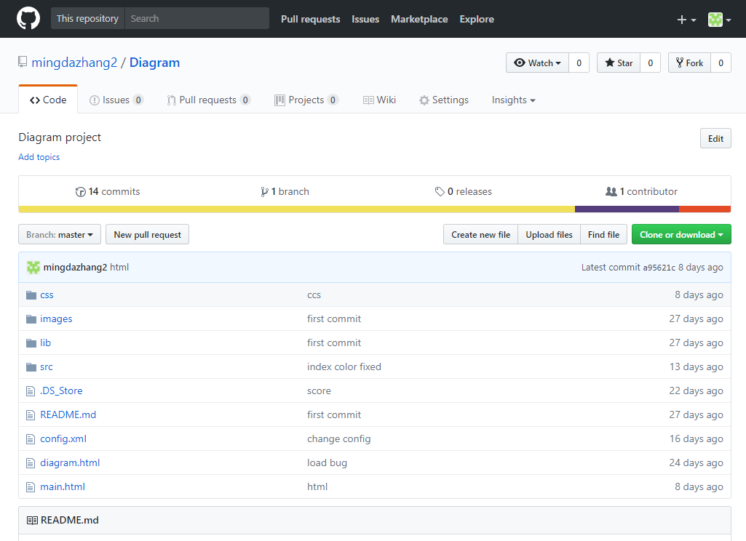

# Conclusion

In conclusion, the project was successful. All the requirements are implemented and got client’s satisfied. In the project, I got experience to communicate to client. In addition, I earned deeper understanding of my major technical skill. However, I have encounter some problems in the project, I finally figure them out and fell quite confident and encouraged. I am looking forward to seeing these quizzes on line.

# Appendices

This section shows the documents that relate to the project report.

**Weekly Report**: This is a general view of my weekly report through the whole semester.

See details in Appendix A.doc

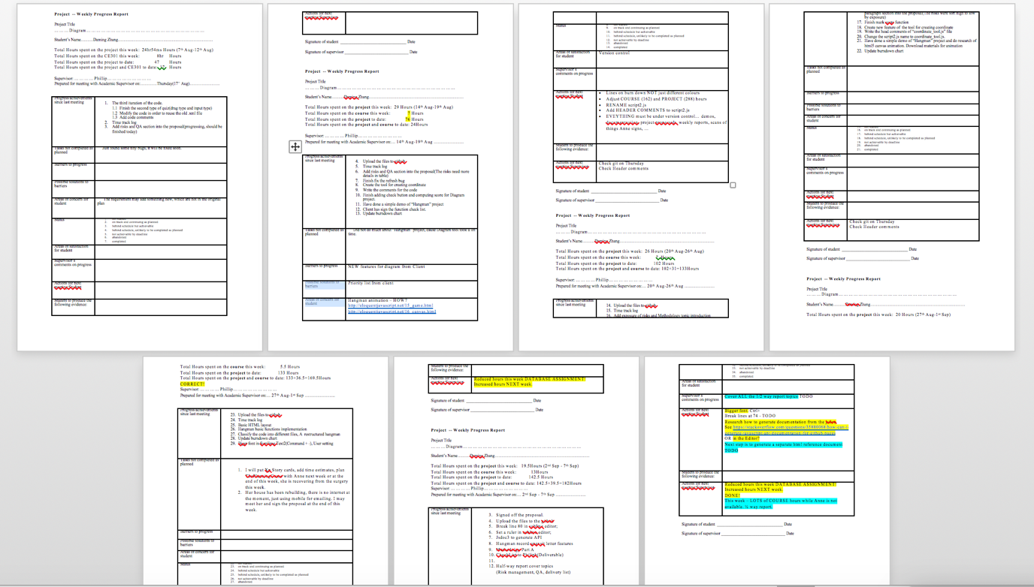

**Weekly Plan**: The picture below shows all my daily plan sheet and one example of them. You can find how I planned before working every week.

See details in Appendix B.xlsx

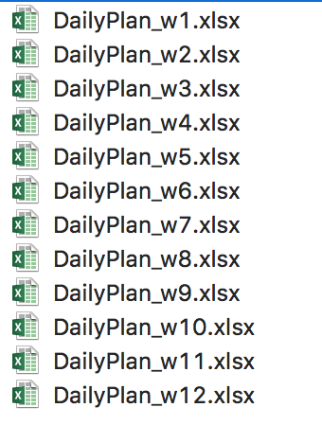

Screen shot of Week 4 plan sheet

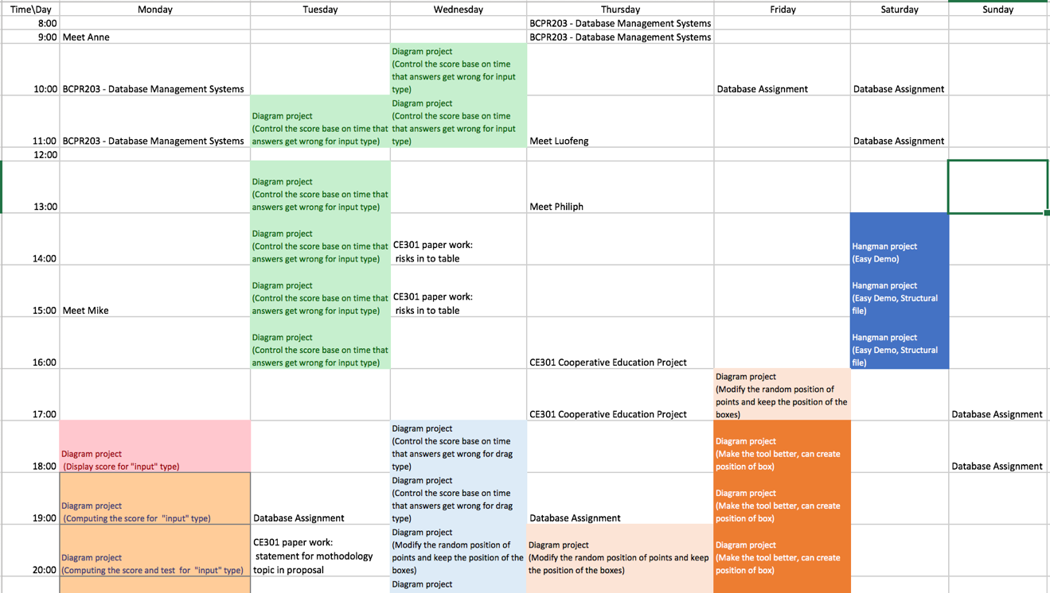

**Deliverable** **list**: See details in Appendix C.doc

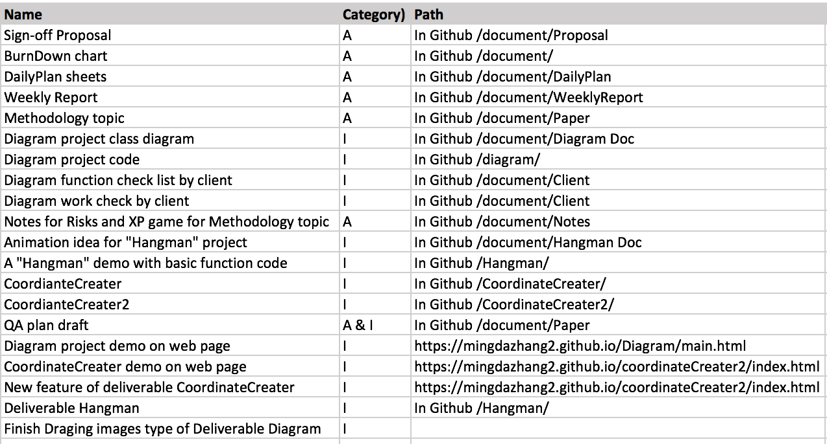

# Reference:

Extreme programming. (2017, October 20). Retrieved October 30, 2017, from https://en.wikipedia.org/wiki/Extreme_programming

Wells, D. (n.d.). Extreme Programming: A Gentle Introduction. Retrieved October 31, 2017, from http://www.extremeprogramming.org/